Kinnaird College for Women, Lahore



BS Computer Science
Pre-Mid
OBJECT ORIENTED PROGRAMMING
Assignment 1

Student Name:
Amna Mushtaq
Roll Number:
F25BSCS037
Section: B
Session: 2025-2029
Submission Date:
26th February, 2026
Course Instructor:
Ms. Mamona Nawaz

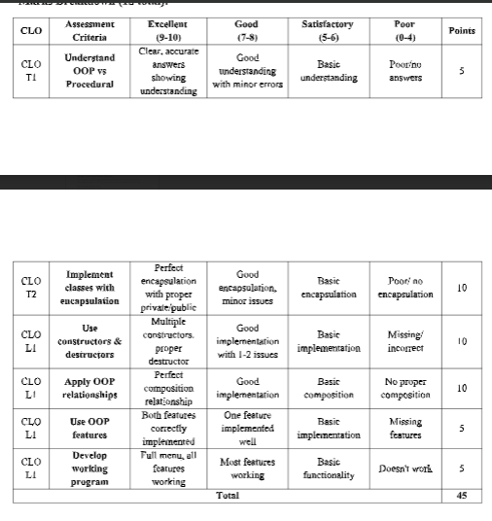

Question 1: Smart Room Manager (40 marks)
You will create a simple program that manages smart devices in a room. Each device is
represented as an object of a Device class, and the room is represented as a Room class.

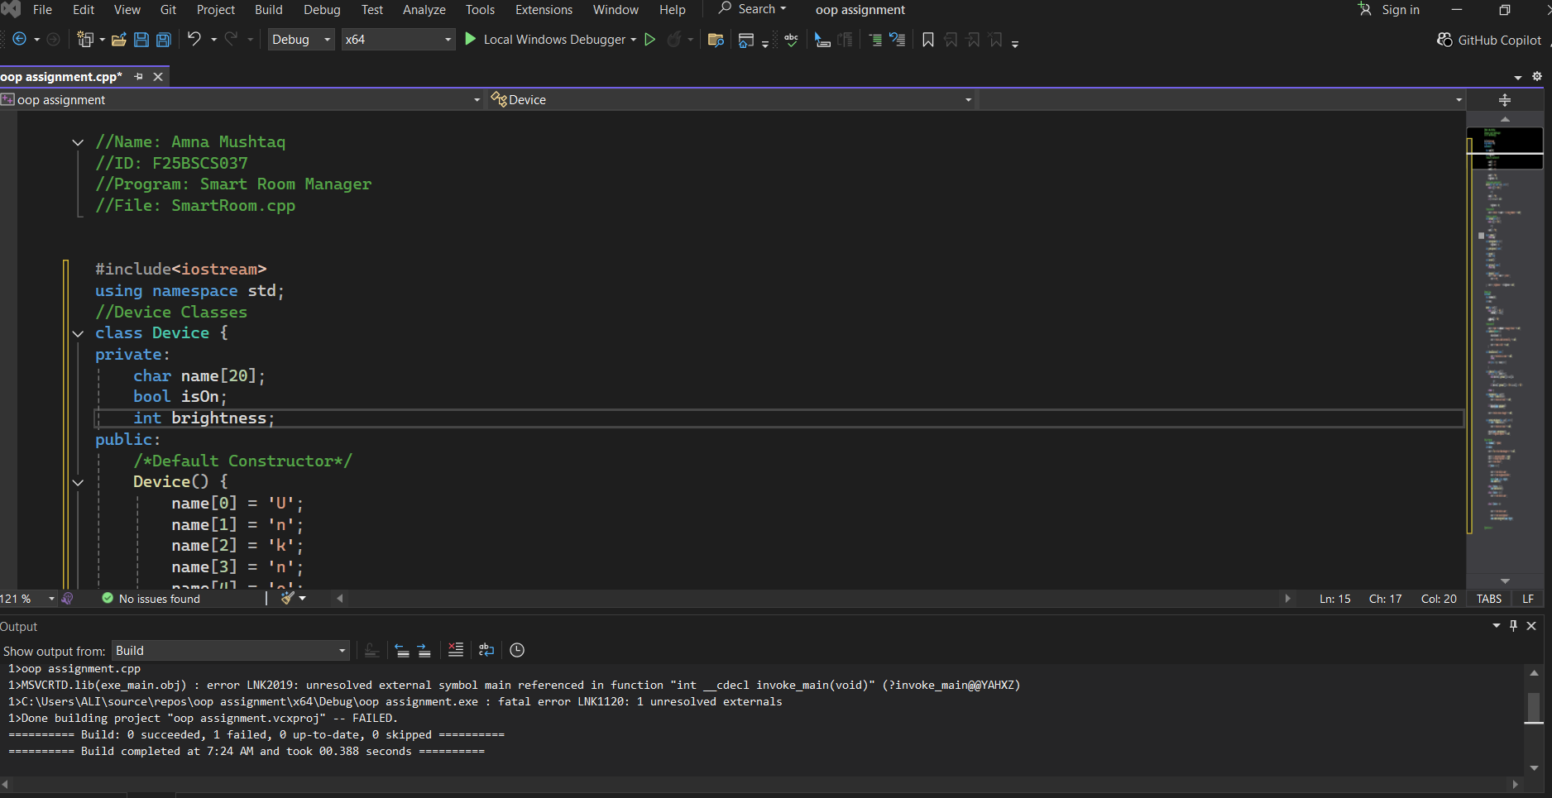
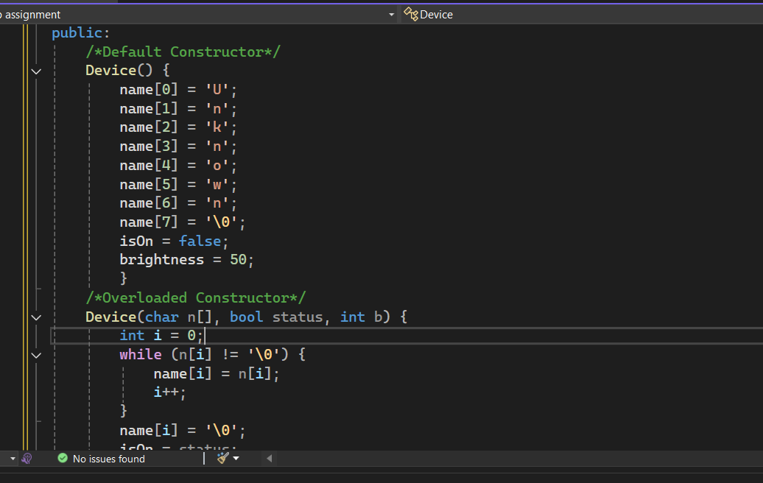
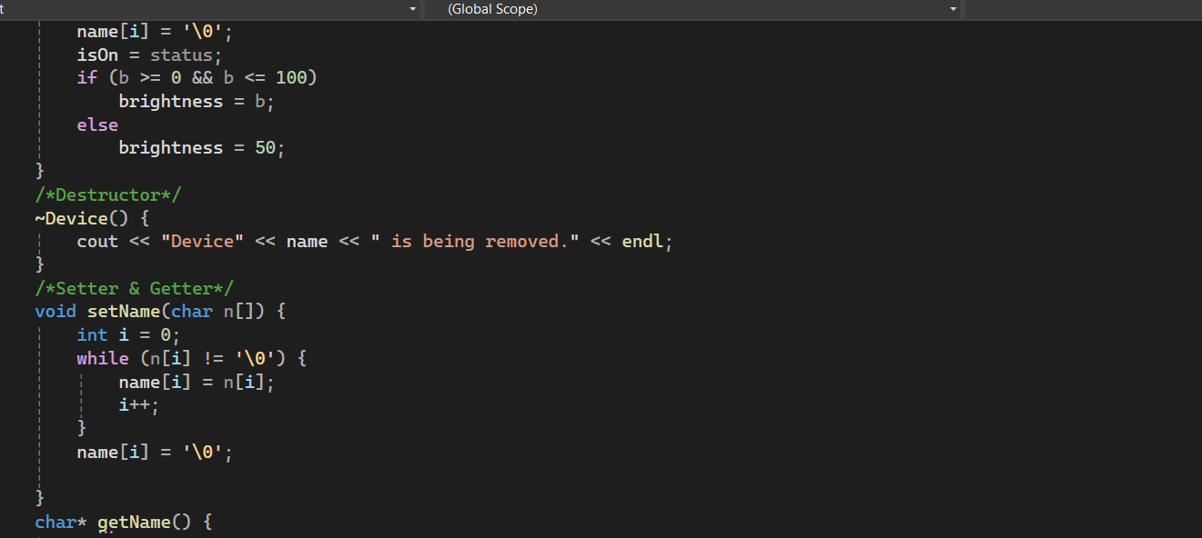
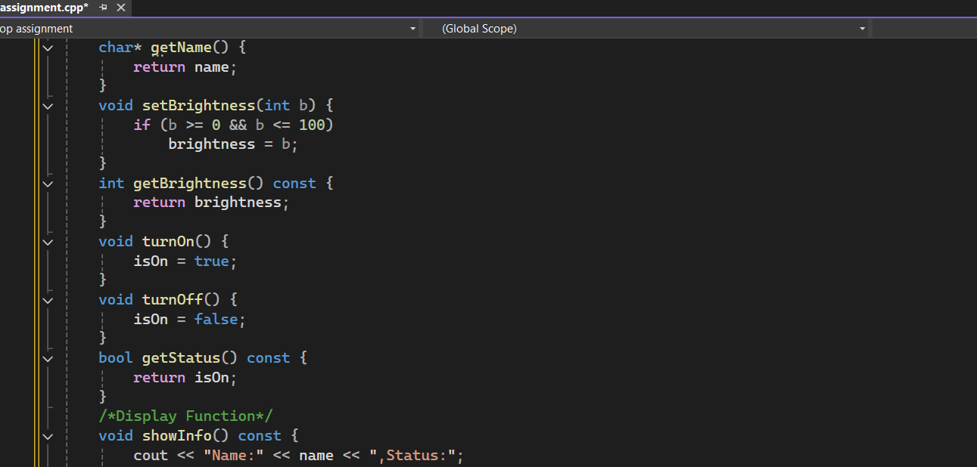
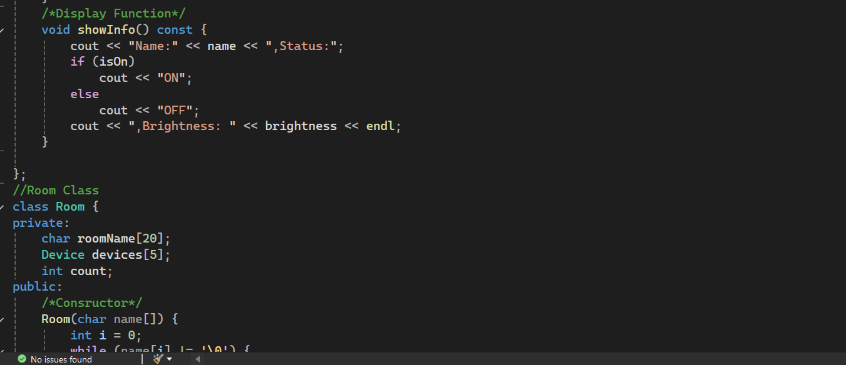
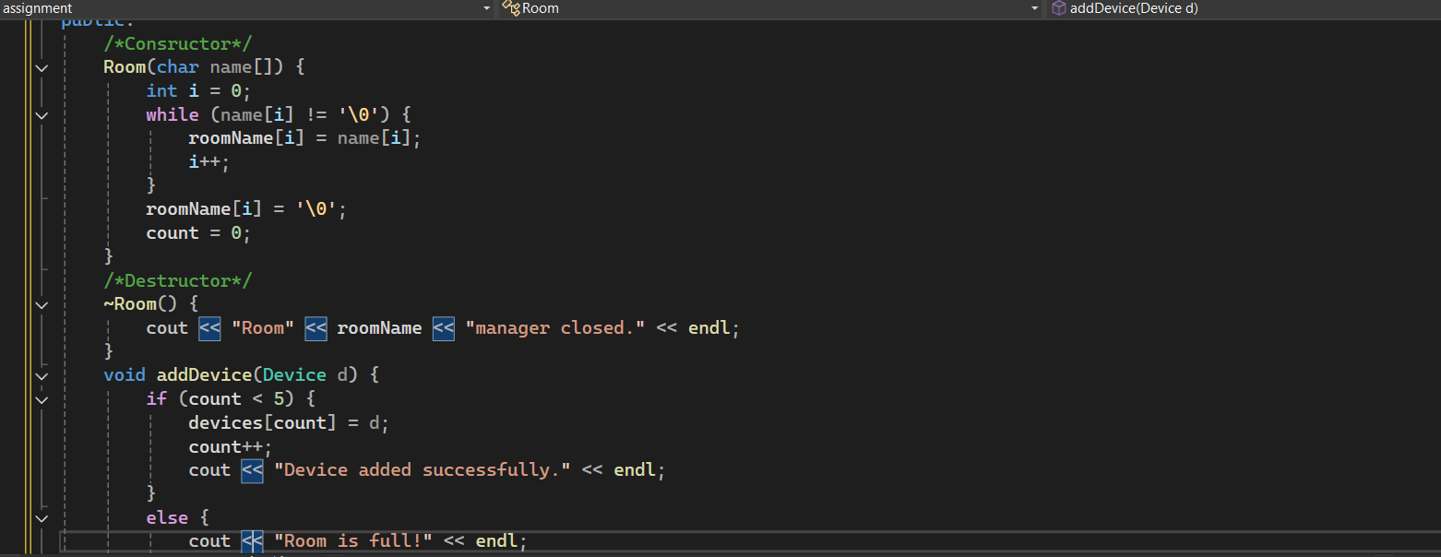
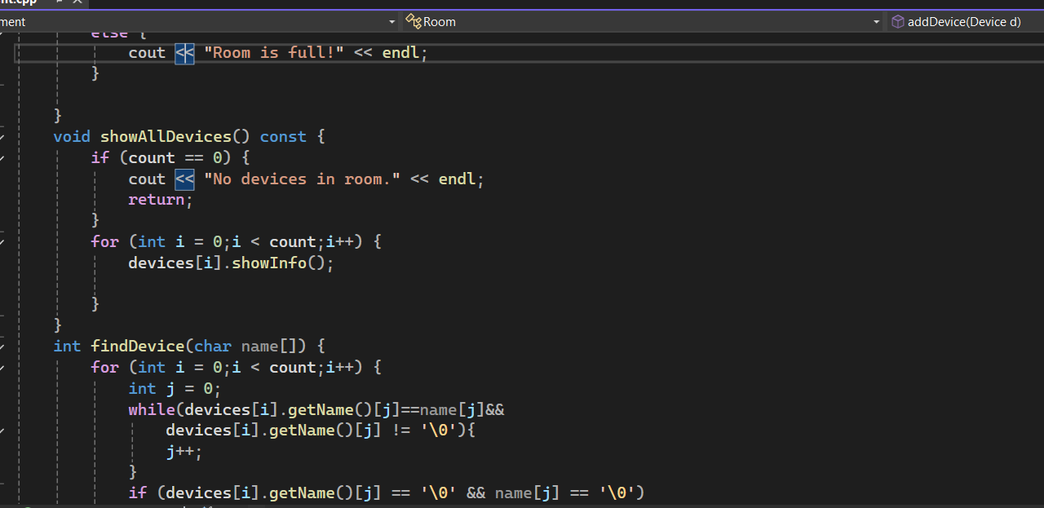
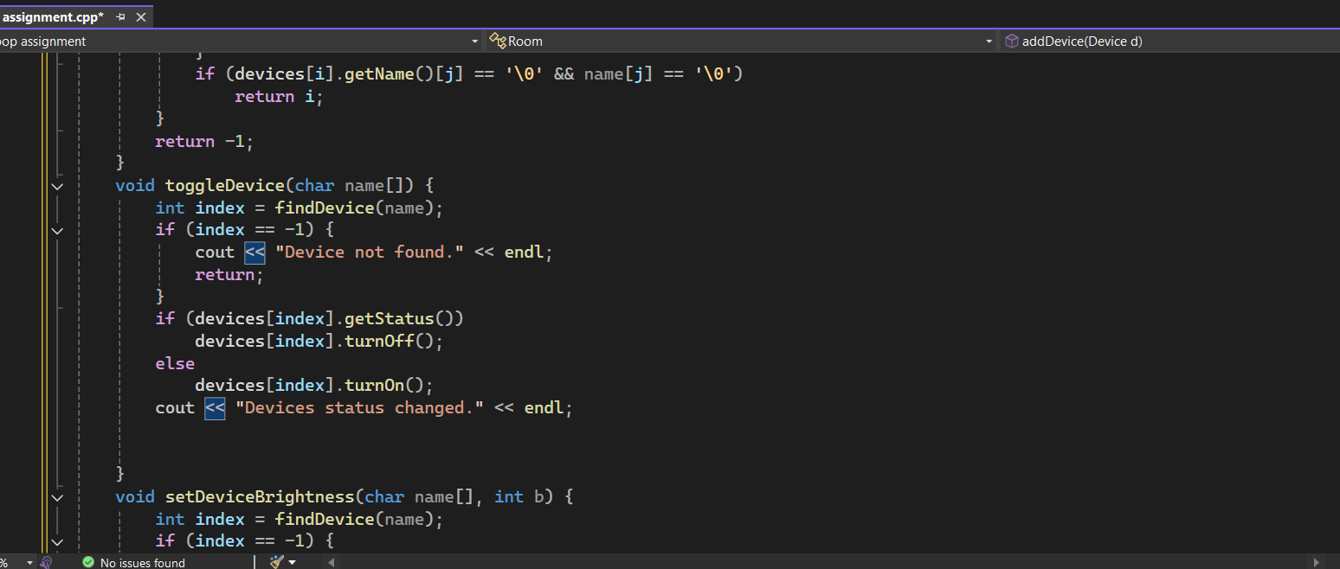
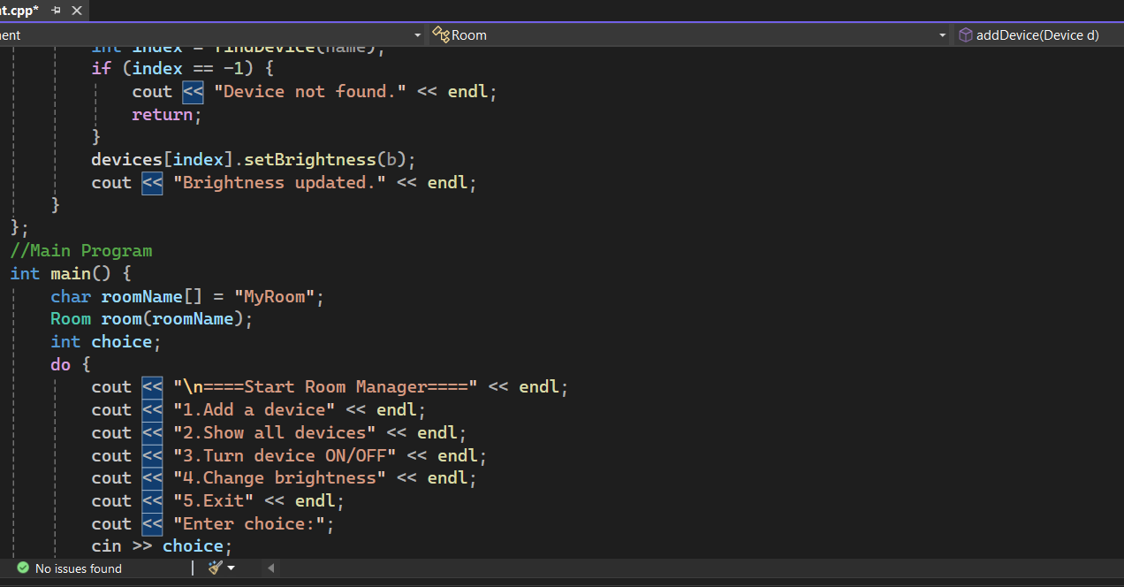
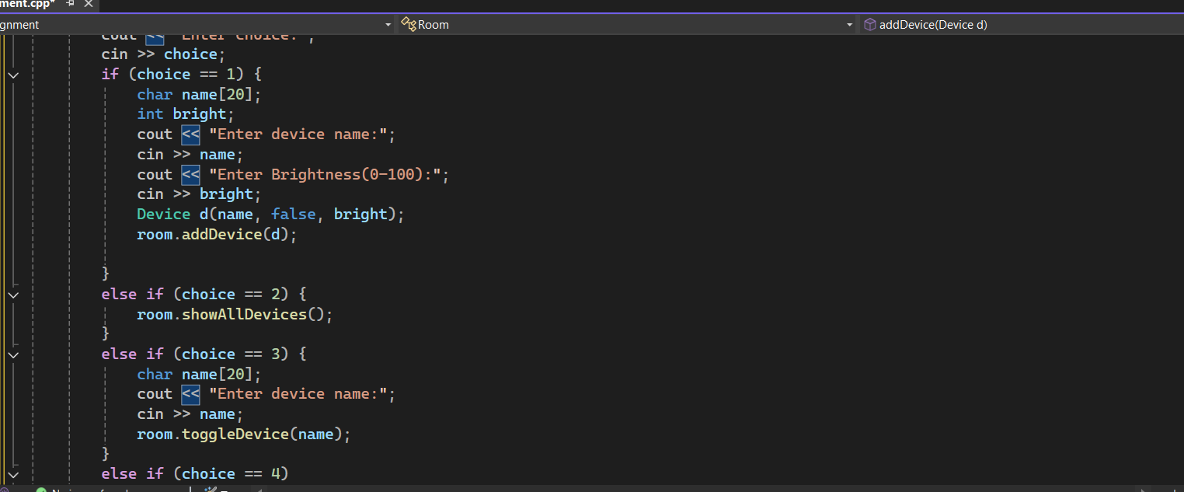

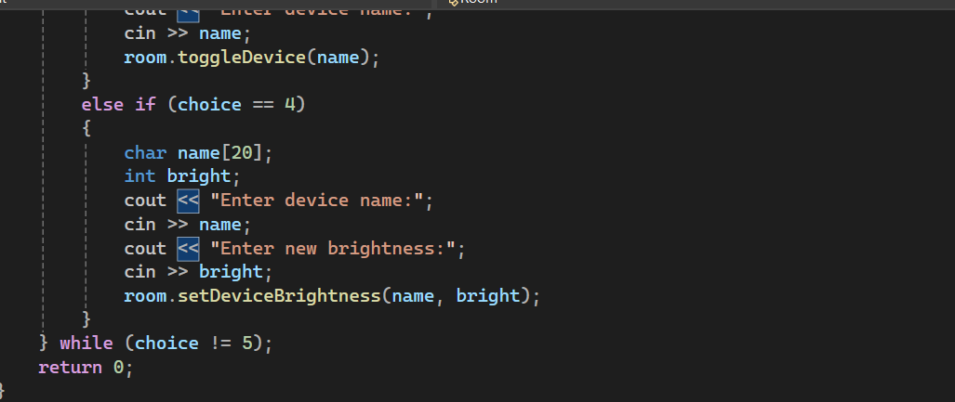

Explanation:
This code is a simple smart room manager program. It has two main classes: Device and Room. The device class represents an electronic device with a name, on/off status, and brightness level. You can turn the device on or off, change the brightness and displays its information. The room class represents the room that can hold up to five devices. It allows you to add device, show all devices in room, find a device by name, toggle its on/off status and change a device’s brightness. The main function provides a menu for the user to manage the room and letting them to add devices, view devices, switch devices on/off and adjust brightness until they choose to exit. Overall, the program helps manage multiple smart device in a room in a simple way.
Question No 2:
  - 1-Main classes and their responsibilities:
Product:
It represents the product on the platform. It is responsible for storing product details like name, ID, price etc.
Customer:
Customer represents a customer. It is responsible for storing customer details like name, email, purchase history etc.
Order:
It represents the order placed by the customer. It is responsible for storing products in the order, total amount, and order status.
Shopping Cart:
It represents customer’s cart. Responsible for adding/removing products and calculating total amount.
  - 2-List of key Data Members:
Product:
name- it’s the name of the product.
Id- it’s the unique product ID.
price-it’s the price of product.
stock-it’s the available quantity.
Customer:
name-it’s customer’s name
email-it’s customer’s email
purchaseHistory- it’s the list of previous order
Order:
products- it’s the list of products in order
totalAmount - it’s the total cost of the order
status-it’s the status of the order e.g pending or completed.
ShoppingCart:
Products-It is the list of products added to the cart.
totalAmount- Total price of product in the cart.
  - 3-Key Member Function(Method):
Product:
showDetails()- it Displays product information
updateStock(int qty)- it change stock quantity.
Customer:
addOrder(Order o)- It adds order to purchase history
viewPurchaseHistory()- It shows previous orders.
Order:
calculateTotal()- It calculates total amount
updateStatus- it change status of the order
ShoppingCart:
addProduct(Product p)- it adds a product to cart.
removeProduct(Product p)- it remove a product form cart.
calculateTotal()-it calculates total price of cart.
  - 4-Relationship between classes:
1-Customer-ShoppingCart (Aggregation):
A customer has a shopping cart but the cart can exist independently.
2-ShoppingCart-Product (Composition):
A cart contains product, if the cart is deleted, its product list is removed.
3-Order-Product (Composition):
An order contains products, deleting the order will remove the product list in that order.
4-Customer-Order (Aggregation):
A customer can have multiple orders, but orders exist independently.
  - 5-Skeleton structure of one class:
class Product {
private:
char name [50]
int id;
float price;
int stock;
public:
Product ();
void setName (char n[]);
void setId(int i);
void setPrice(float p);
void setStock(int s);
void display();};